**COMPUTER ARCHITECTURE AND ORGANIZATION CEN-221**

**LAB-2 (Conditional Statement)**

**TASK-1:** Take any integer as input, if the number is greater than 5 print it,

* + - if a>5 print a
    - Else if a = 0, then Halt
    - Else if a < 5, then halt

**Code:**

IN

STO 10

LDA 10

SUB 11

BRZ 06

BRP 07

HLT

LDA 10

OUT

*11

DAT 005

**Output:**

**If a > 5:**

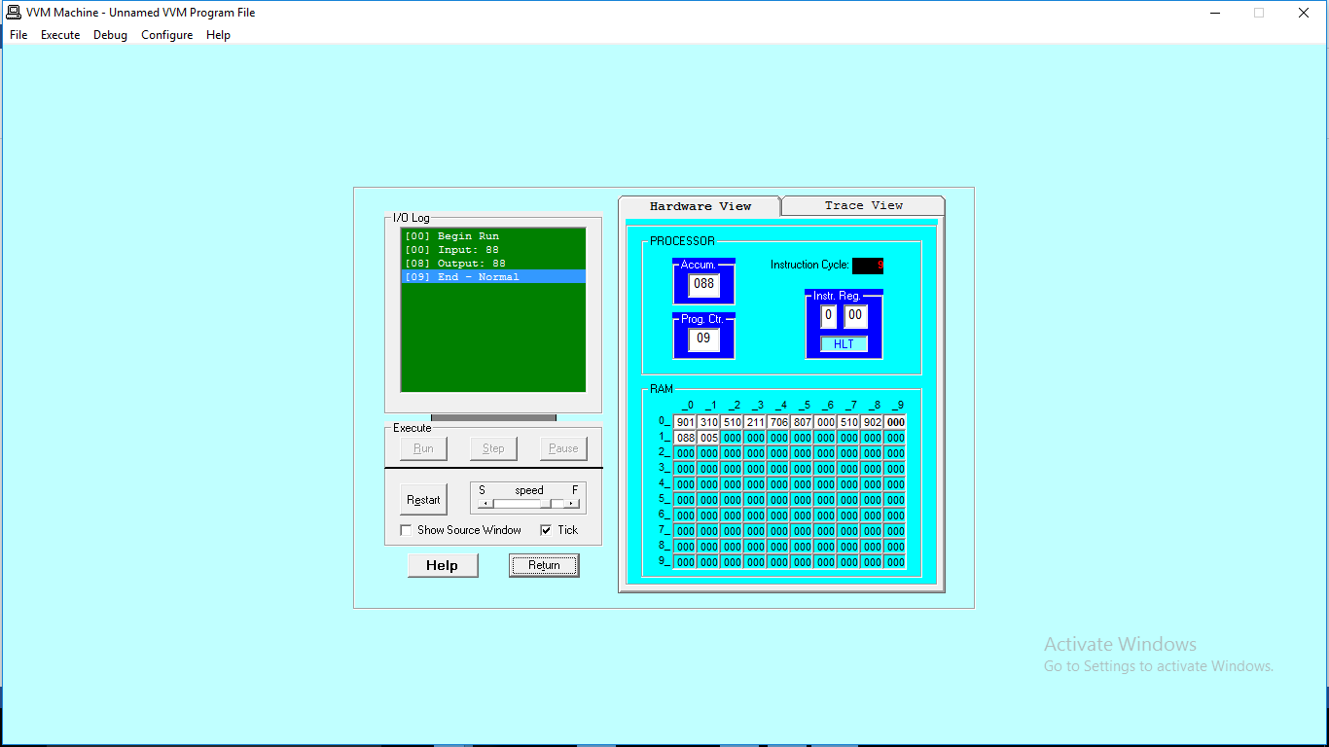

**Else if a = 0, then Halt:**

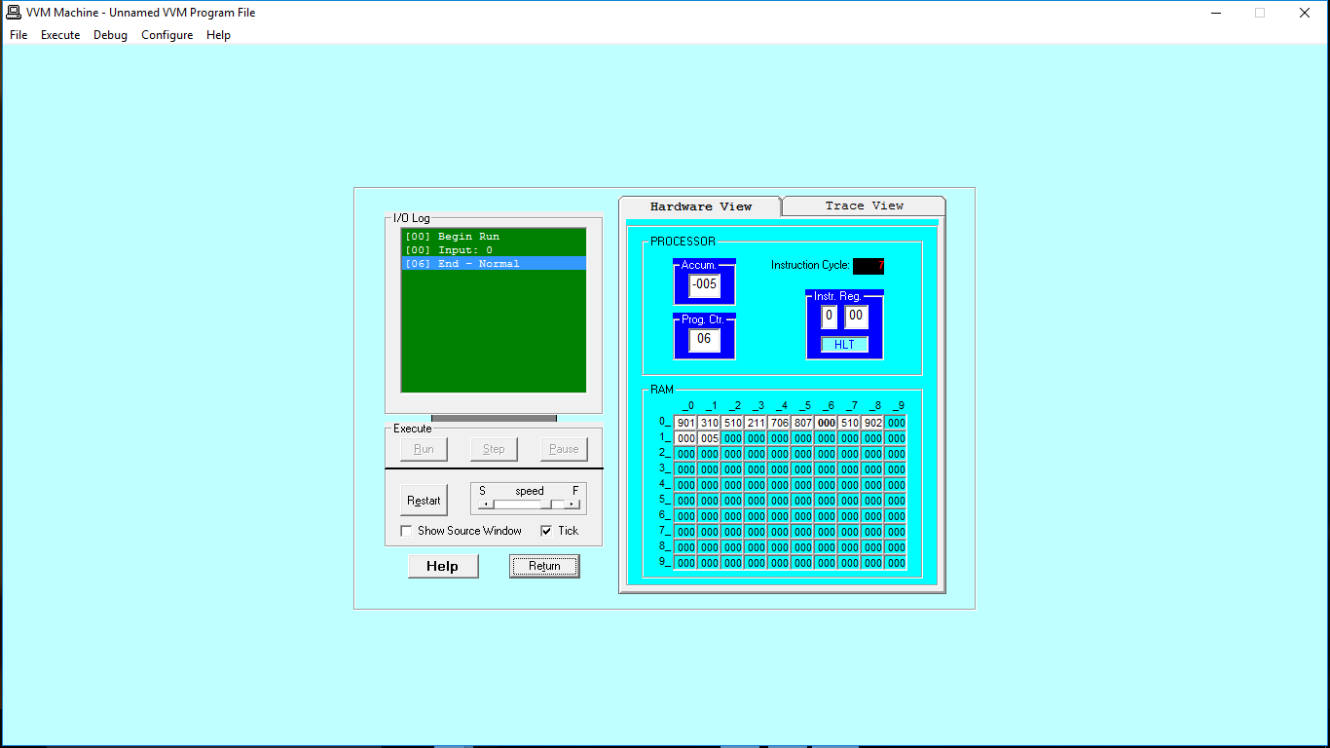

**Else if a < 5, then Halt:**

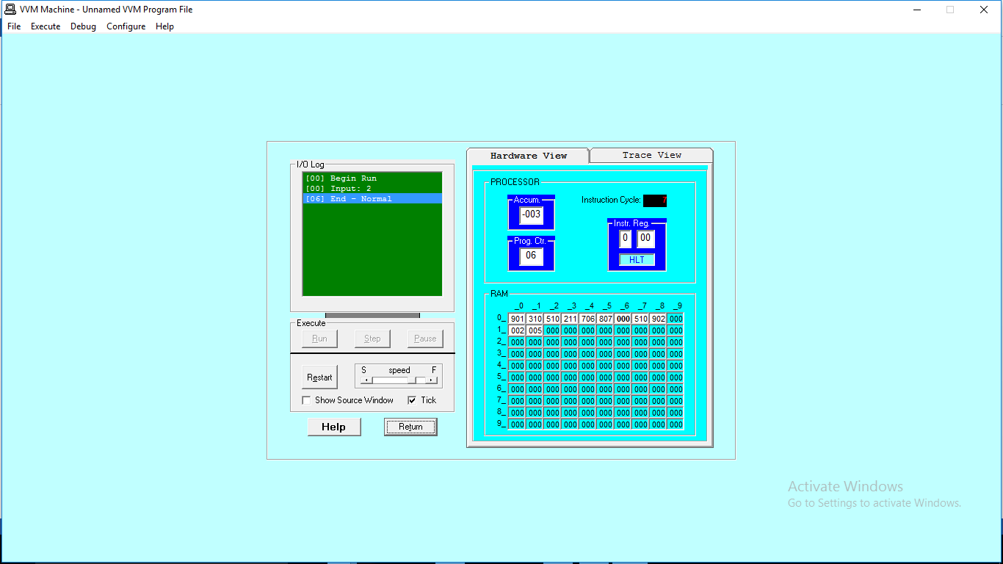

**TASK-2:** Take two inputs and print the larger number.

**Code:**

IN

STO 10

IN

STO 11

LDA 10

SUB 11

BRP 07

LDA 11

OUT

HLT

LDA 10

OUT HLT

**Output:**

